***The USA***

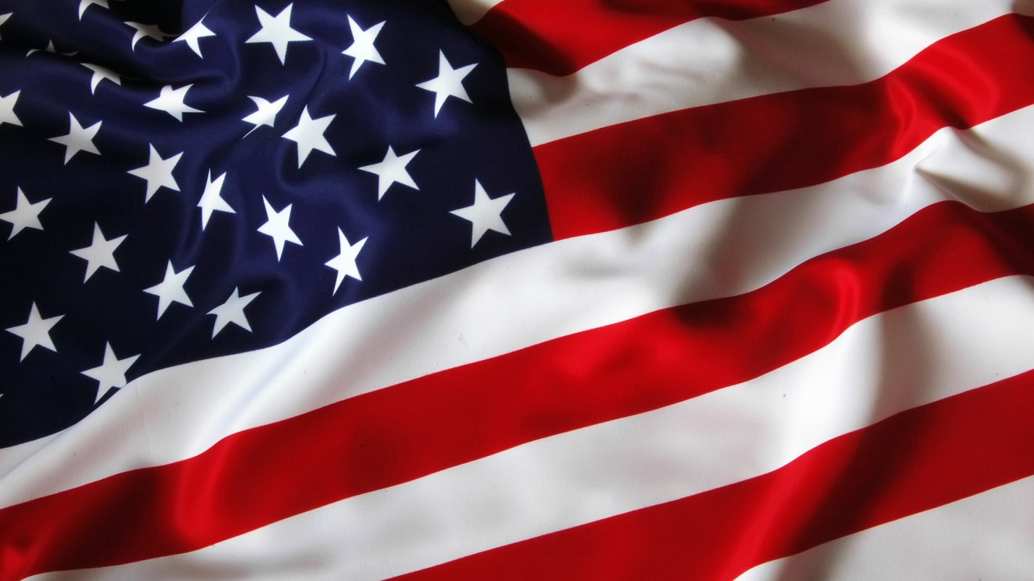

*The United States of America is the fourth largest country in the world (after Russia, Canada, and China). It occupies the southern part of North America and stretches from the Pacific to the Atlantic Ocean. It also includes Alaska in the north and Hawaii in the Pacific Ocean. The total area of the country is about nine and a half million square kilometres. The USA borders on Canada in the north and on Mexico in the south. It also has a seaboarder with Russia.*

*The USA is made up of 50 states and the District of Columbia where the capital of the country, Washington, is situated. The population of the country is about 250 million.*

*If we look at the map of the USA, we can see lowlands and mountains. The highest mountains are the Rocky Mountains, the Cordillera, and the Sierra Nevada. The highest peak is Mount McKinley, which is located in Alaska.*

*America's largest rivers are the Mississippi, the Missouri, the Rio Grande, and the Columbia. The Great Lakes on the border with Canada are the largest and deepest in the USA.*

*The climate of the country varies greatly. The coldest regions are in the north. The climate of Alaska is arctic. The climate of the central part of the country is continental. The south has subtropical climate. Hot winds blowing from the Gulf of Mexico often bring typhoons. The climate along the Pacific coast is much warmer than that of the Atlantic coast.*

*The USA is a highly developed industrial country. It is the leading producer of copper and oil and the worlds second producer of iron ore and coal. On the industrial enterprises of the country they produce aircrafts, cars, textiles, radio and television sets, weapon, furniture, and paper.*

*Though mainly European and African in origin, the Americans are made up from nearly all races and nations, including the Chinese and the native Americans — Indians.*

*The largest cities are New York, Los Angeles, Chicago, Philadelphia, Detroit, San Francisco, and others.*

*The United States is a federal republic consisting of 50 states, each of which has its own government. The seat of the central (federal) government is Washington, D. C. According to the Constitution of the USA, the powers of the government are divided into 3 branches: the executive, headed by the President, the legislative, exercised by the Congress, and the juridical. The Congress consists of the Senate and the House of Representatives. There are two**main political parties in the USA: the**Republican and the Democratic.*

