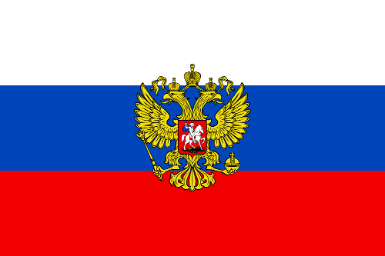

***My country in the world.***

***This is Russia!***

Russia is one of the largest countries in the world.

The vast territory of the Russian Federation stretches from the Baltic Sea in the West to the Pacific Ocean in the East, from the Arctic Ocean in the North to the Black Sea in the South.

The capital of Russia is Moscow. It is the most important political, industrial, scientific and cultural centre of the country.

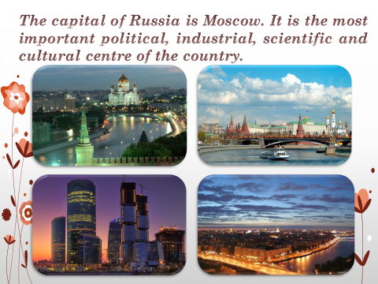

Russia is a country of thick forests, high mountains and long rivers. The longest rivers are Volga and Ob, Yenissei and Lena.

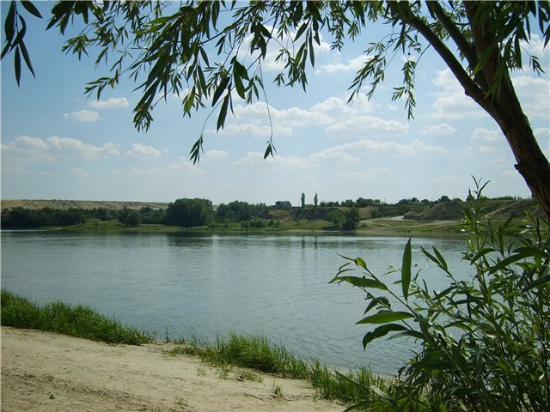

Lake Baikal is the biggest and the deepest in the world.

It is famous for its crystal clean water.

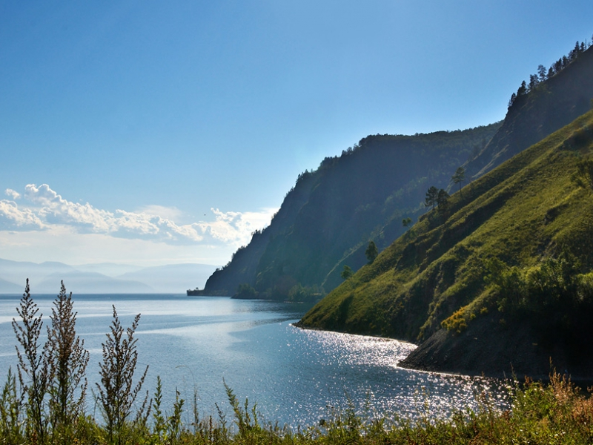

Our country has a glorious history. Russian people suffer from many wars.

But they have never attacked any other country.

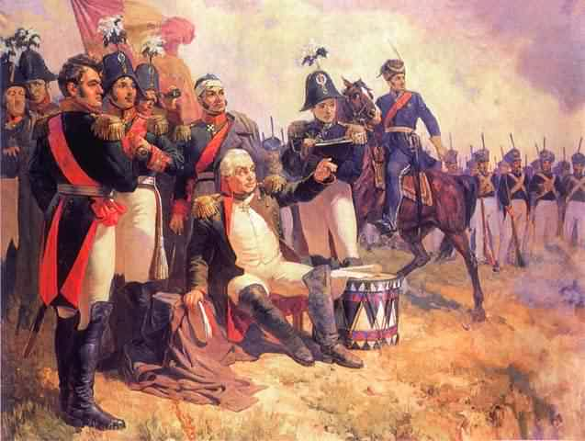

Nowadays Russia remains a powerful state enjoying a high reputation among other nations of the world.

It plays an important part in the Commonwealth of Independent States (CIS).

