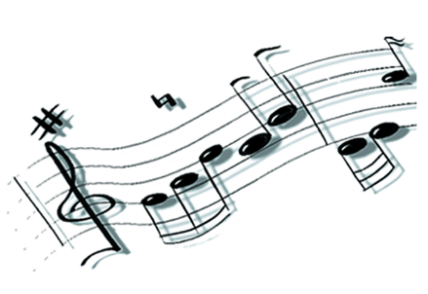**SING TOGETHER! ____________________________________**

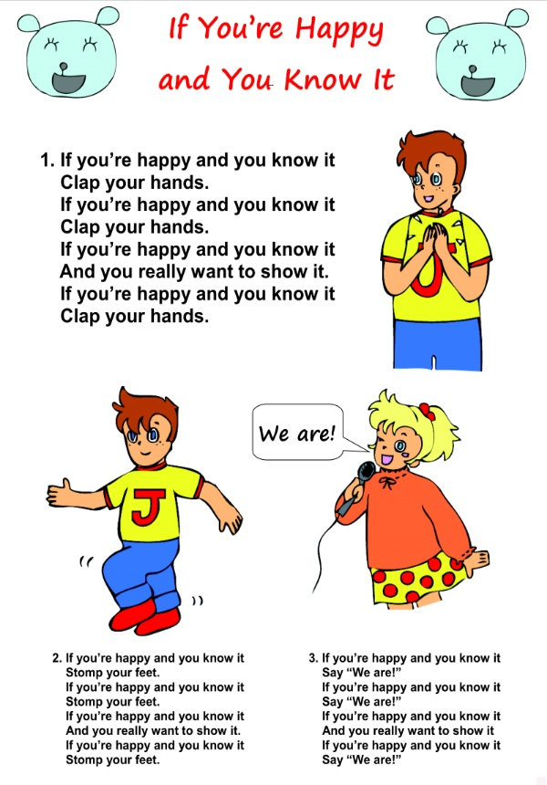

**SING TOGETHER!**

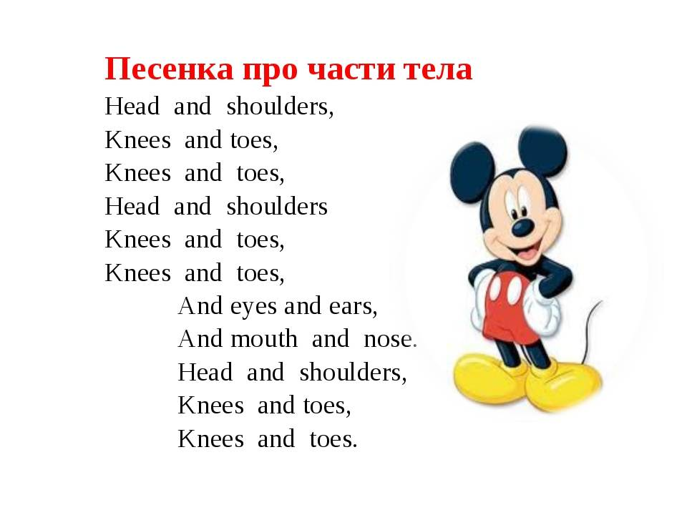

**SING TOGETHER!**

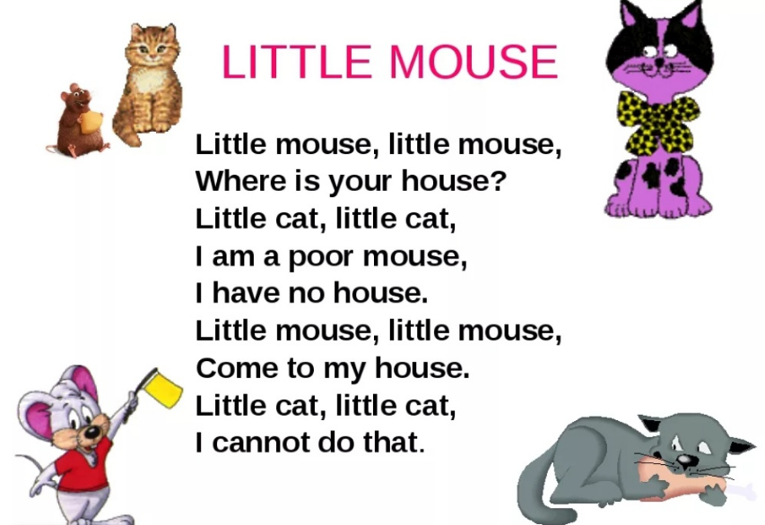

**SING TOGETHER!**

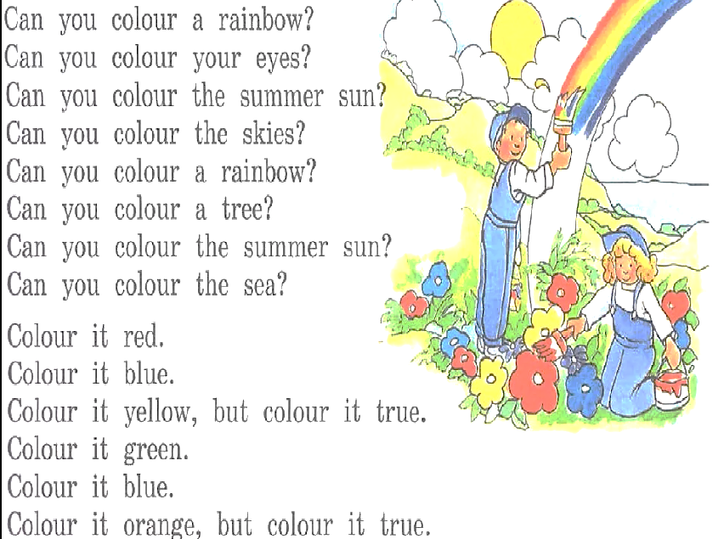

**SING TOGETHER!**

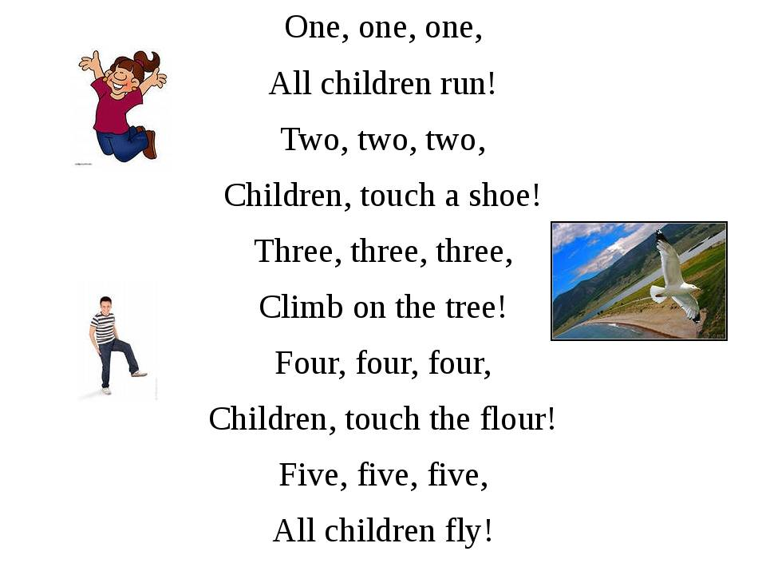

**SING TOGETHER!**

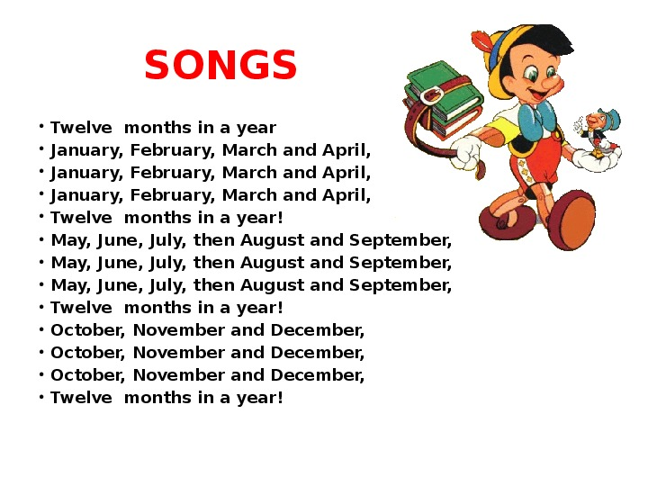

**SING TOGETHER!**

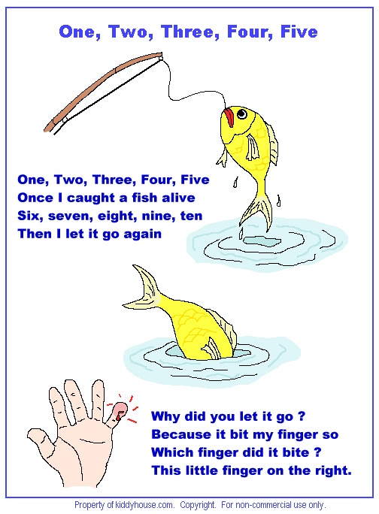

**SING TOGETHER!**

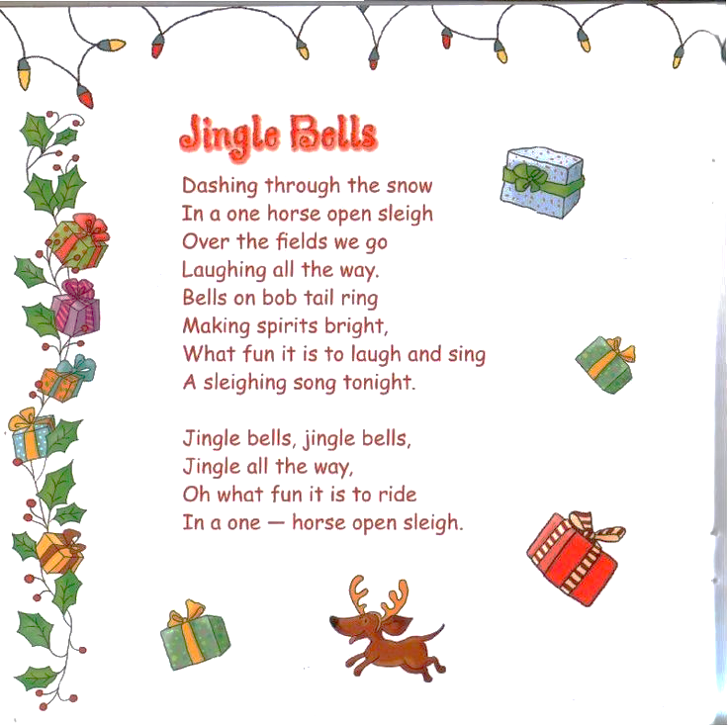

**SING TOGETHER!**

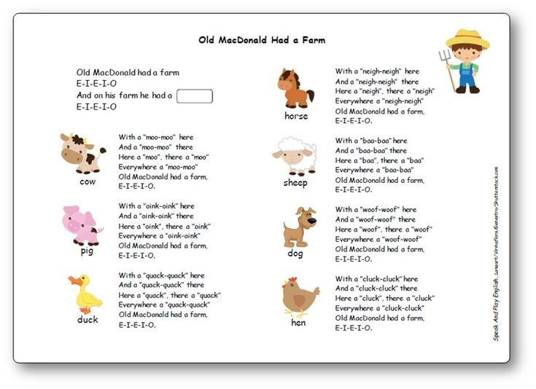

**SING TOGETHER!**



